Team Member 1: Mansi Negi [e23cseu1706]
Team Member 2: Shashwat Tyagi [e23cseu2331]

SYSTEM ARCHITECTURE
MediScribe – LLM-Based Clinical Text Generation System

1. Introduction
The MediScribe system is designed to automate medical report generation using Generative Artificial Intelligence. It generates structured clinical reports from patient input using a Large Language Model (LLM) through the Google Gemini API.
Healthcare professionals often spend significant time writing reports manually. This system helps reduce that effort by automatically generating readable and structured reports, improving efficiency and consistency.

2. Architecture Overview
The MediScribe system follows a modular architecture consisting of:
- User Interface (Frontend)
- Input Processing
- Prompt Construction
- Backend (API Route)
- Large Language Model (Gemini API)
- Output & PDF Generation
The system connects user input with AI processing to generate real-time clinical reports.
3. System Components
3.1 User Interface Module
The user interface allows users to interact with the MediScribe system. It is implemented using Streamlit, which provides a simple web-based interface for entering clinical information.
Users can provide the following structured medical information:
- Patient symptoms
- Diagnosis
- Medication details
- Additional observations
This information is submitted to the system for processing and report generation.
3.2 Input Processing Module
The input processing module prepares the structured medical information for the language model.
This step involves:
- Cleaning and formatting the input text
- Organizing the information into structured fields
- Preparing the data for prompt construction
The processed data is then forwarded to the prompt construction module.
3.3 Prompt Construction Module
In this stage, the structured clinical information is converted into a natural language prompt that can be understood by the language model.
For example:
Symptoms: Fever, cough
Diagnosis: Viral infection
Medication: Paracetamol
This information is converted into a prompt that instructs the model to generate a clinical report. Prompt engineering helps guide the language model to produce structured and meaningful output.
3.4 Large Language Model Module
The system uses Google Gemini (LLM) via API.
It:
- Understands natural language
- Analyzes symptoms
- Generates structured clinical reports
No model training is done in the project — only API integration is used.
3.5 Backend Module
The backend is implemented using Next.js API Routes.
It:
- Receives input from frontend
- Sends request to Gemini API
- Handles response
- Manages errors

4. System Workflow
The workflow of MediScribe is as follows:
- User enters symptoms and details through the interface
- Input is processed and structured
- Prompt is generated from input
- Request is sent to backend API
- Backend calls Gemini API
- AI generates clinical report
- Report is displayed and can be downloaded as PDF

5. Architecture Diagram
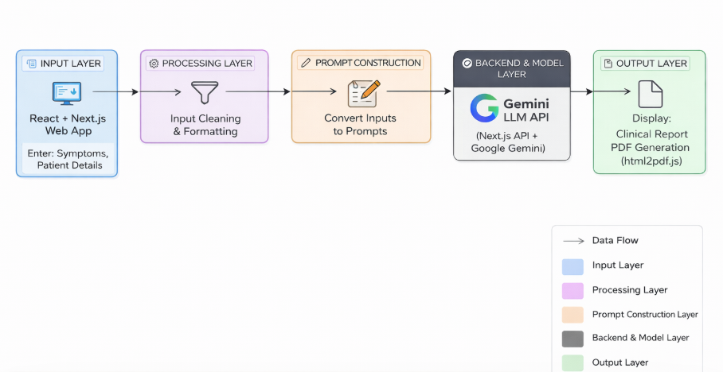
6.Conclusion
The MediScribe system demonstrates how Generative AI can be integrated into a modern web application to automate clinical report generation.
By using a pre-trained LLM (Gemini API), the system provides fast, structured, and user-friendly medical reports without requiring model training.
This architecture highlights the practical use of AI in real-world applications.

